How to create golden AMI from normal EC2 instance and create a instance from AMI
create one instance and install the any application
Eg docker

Docker installation command
sudo yum install docker -y
sudo systemctl start docker
sudo systemctl enable docker
sudo systemctl status docker
sudo usermod -aG docker ec2-user
docker --version
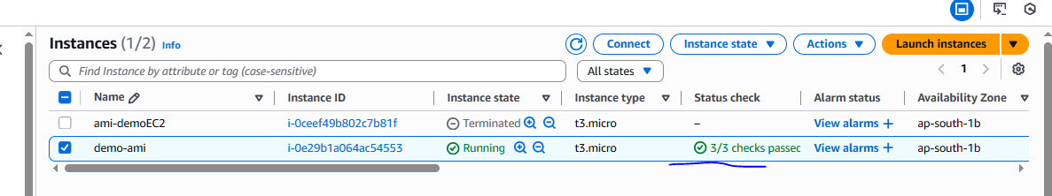
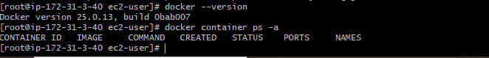
From EC2 instance create a AMI
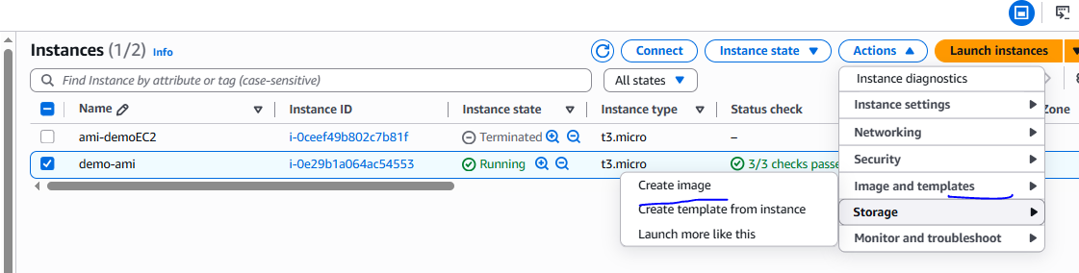

AMI created
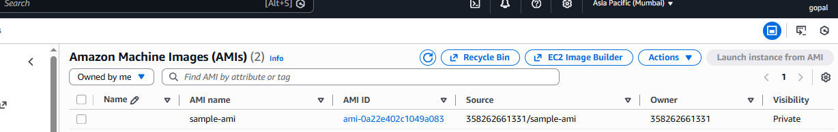
Then terminate the instance

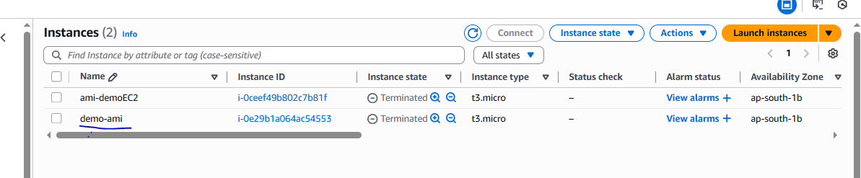

Create one new instance from golden AMI and launched
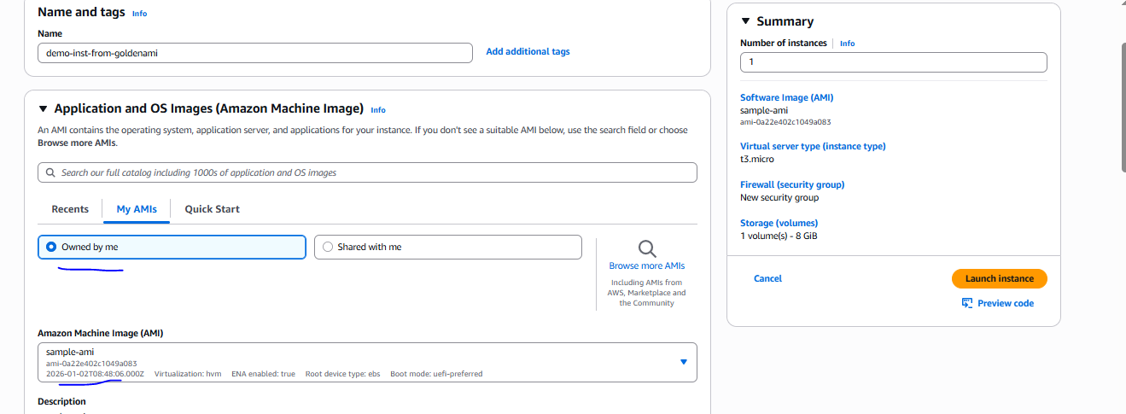

Verified
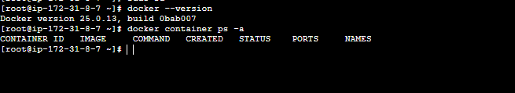

How to change the subnet using AMI in same region of EC2 instance
